**Class diagram:**

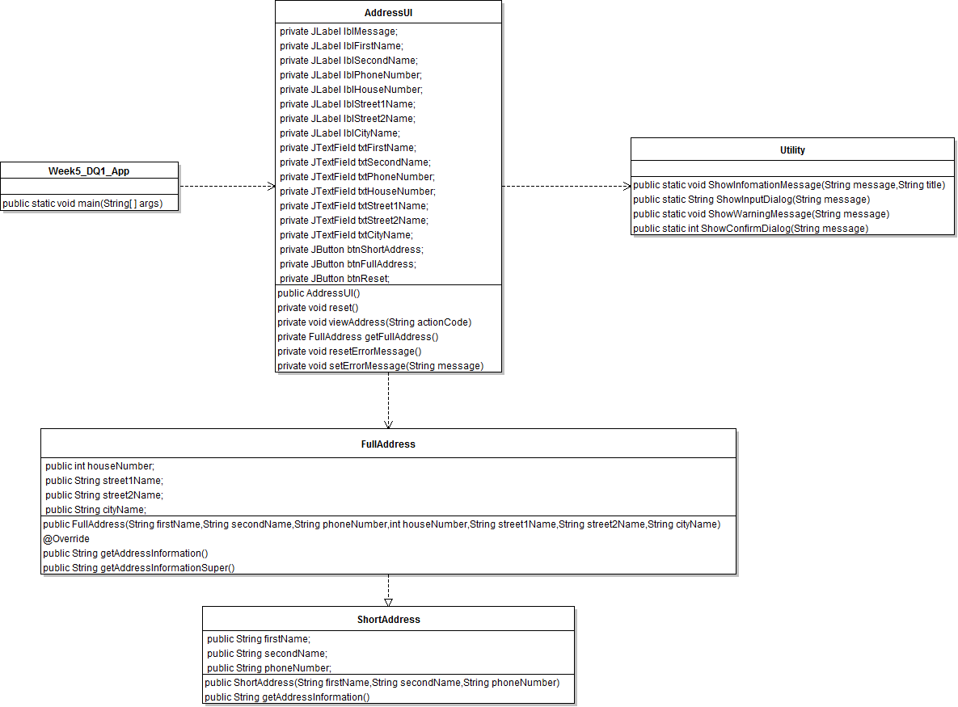

1. **Week5_DQ1_App**

It is a driven class to start the application

1. **AddressUI**

This class will construct the UI elements as well as interact with user

* Get address info from user input
* Display short or full address info

1. **ShortAddress**

This class includes basic address info such as first name, second and phone number

1. **FullAddress**

This class inherit from short address and contains additional address info such as street name, city name…etc